I started by creating a slice in Fabric testbed.

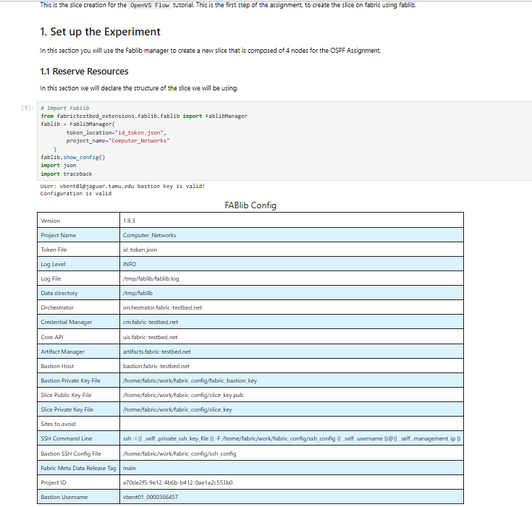

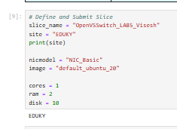
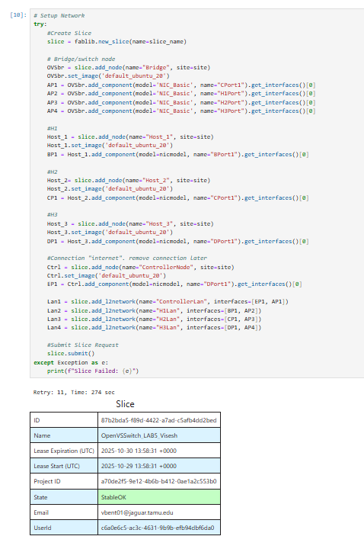
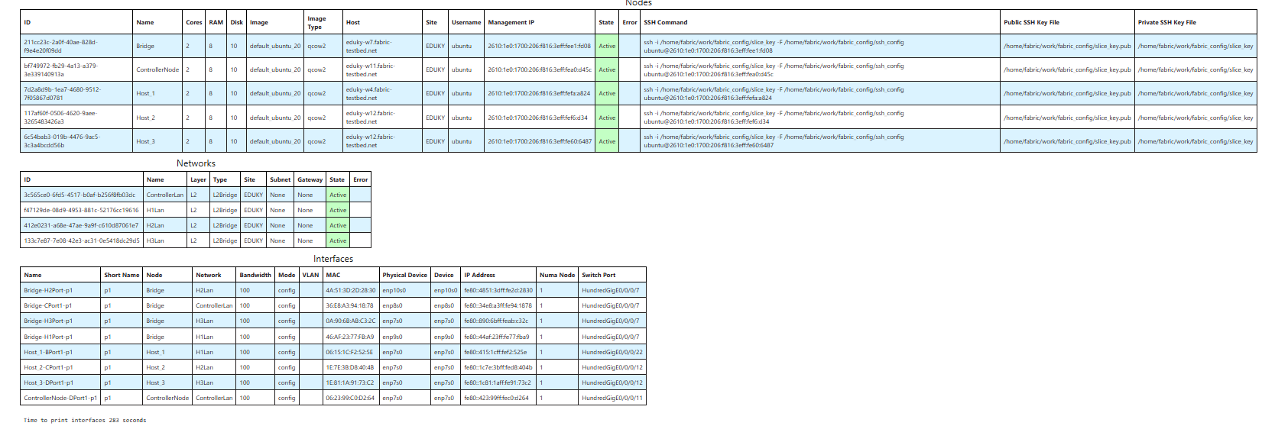
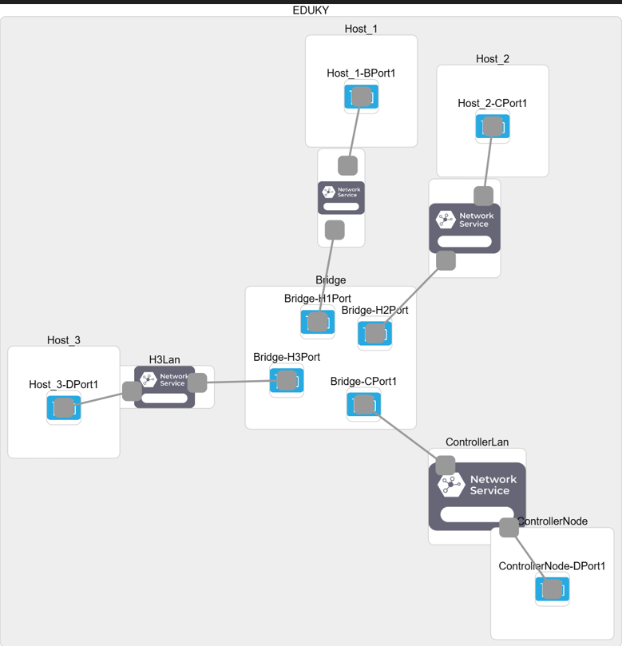

After Successfully creating a slice, now we set up the experiment network
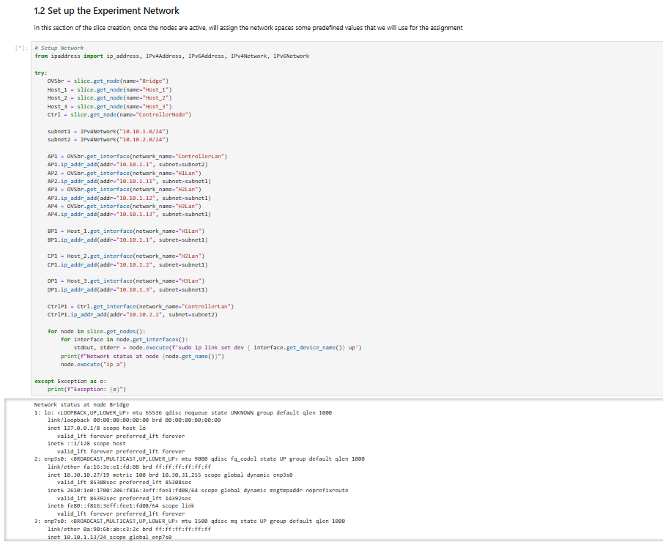
Now we configure the software needed for the nodes
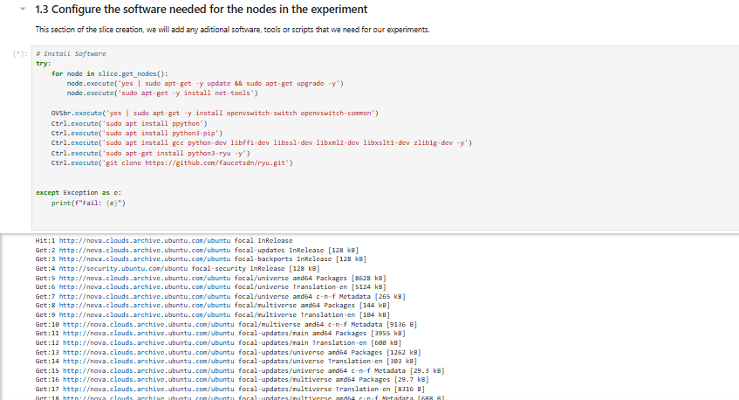

After everything we load the OpenVS notebook and continue the remaining experiment there.
We retrieve the slice we created
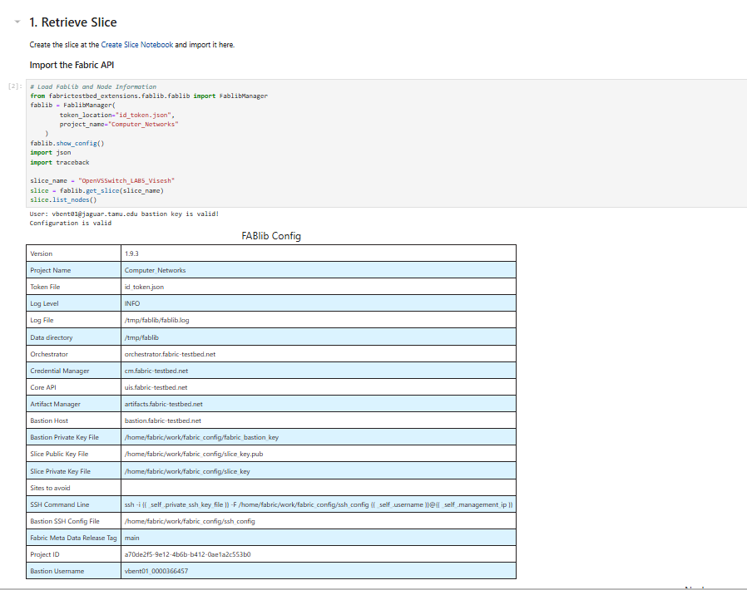

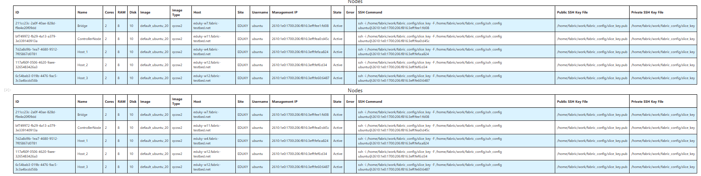

2. Guided Experiment
2.1. Login to your hosts and preconfigurement
1.Login to the OVS host (bridge node)
2.Create an Ethernet bridge that will act as our software switch in a terminal using the SSH key:
Command: sudo ovs-vsctl add-br br0

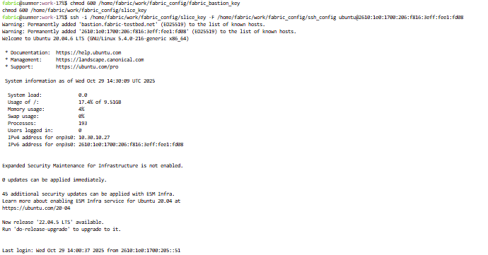
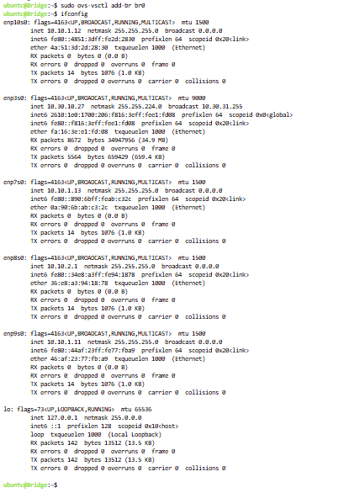
Remove IP Addresses from Data Interfaces: Set the IP addresses of the data interfaces to 0 to prepare them for the OVS bridge:
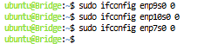
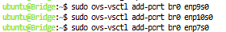
2.1. Point your switch to a controller
I Logged in to my controller
Find the control interface IP of your controller, use ifconfig and note down the IP address of eth0, Using the ssh command
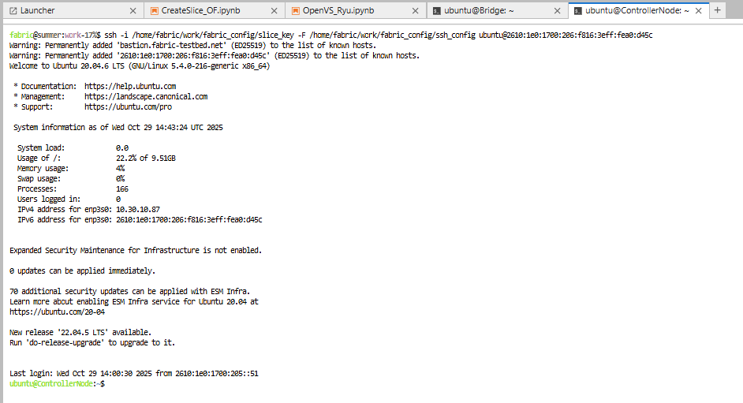
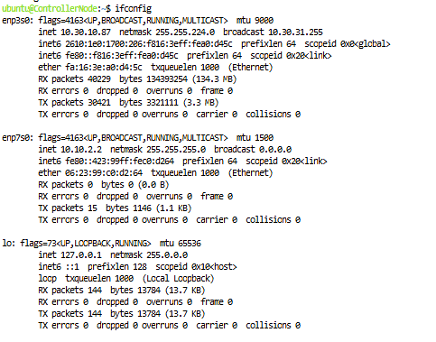
I set my switch to fail-safe-mode. For more info read the standalone vs secure mode section. I Ran: sudo ovs-vsctl set-fail-mode br0 secure, Trust but verify.
I verified OVS settings by issuing the following:
sudo ovs-vsctl show
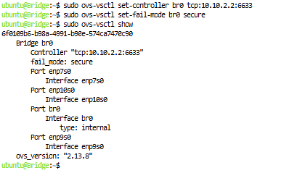

2.2 Use a Learning Switch Controller
In this example we are going to run a very simple learning switch controller to forward traffic between host1 and host2.
- First start a ping from host1 to host2, which should timeout, since there is no controller running.
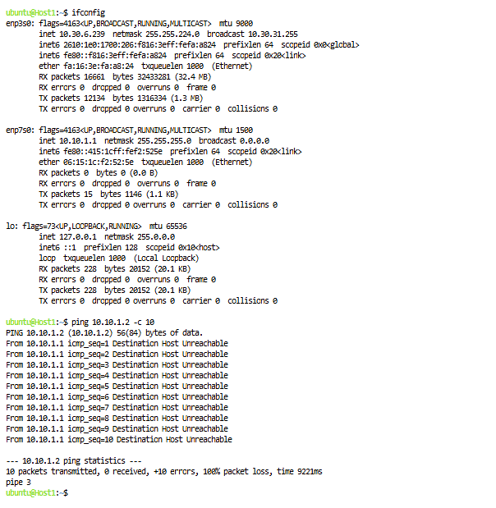
I installed ryu controller in the ControllerNode terminal

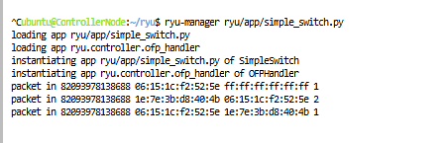
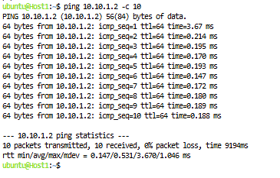
2.3 Look around your OVS switch
If you are using OVS, to see the flow table entries on your OVS switch: sudo ovs-ofctl dump-flows br0.
By running tcpdump on the controller node, we can monitor the traffic between the OVS switch and the controller:
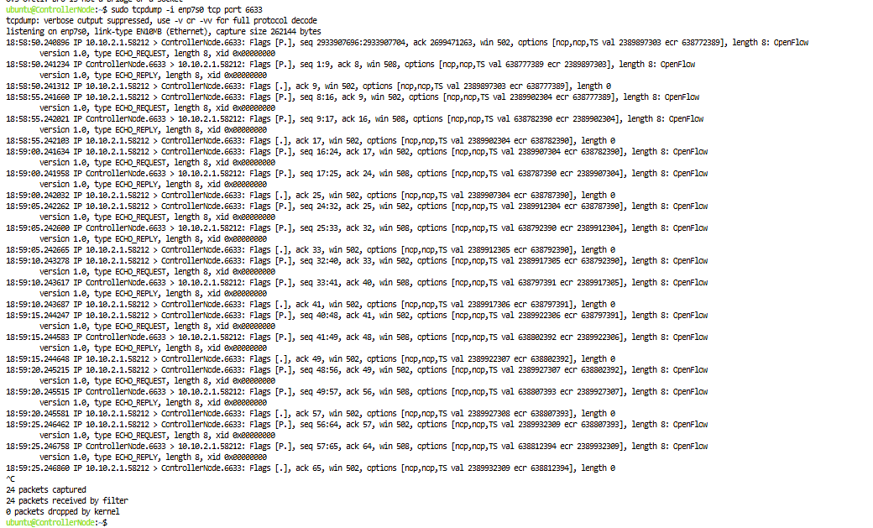
Notice what happens to ping on host1.
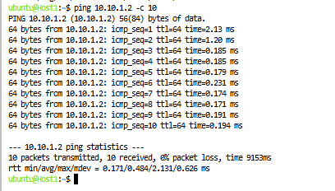
Q) Can you tell now why there were packets flowing even after you killed your controller?
Packets kept flowing even after the controller was stopped because the switch still had active flow rules. These rules didn’t expire since their hard timeout was set to infinity, meaning they stay in place permanently unless removed manually. The soft timeout also didn’t remove them because packets were still being sent, so the switch kept forwarding traffic even without the controller running
Check the flow table entries on your switch: sudo ovs-ofctl dump-flows br0 You will see flow table entries in the switch. The entries time to expire value is set to infinity. And then Delete the entries on the OVS using: sudo ovs-ofctl del-flows br0
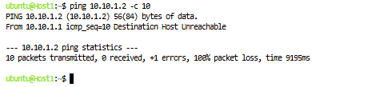
Now we saw the packetloss.

2.4 Download the Ryu apps
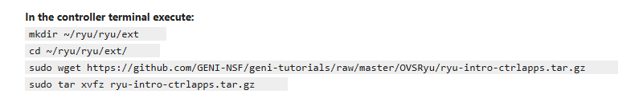
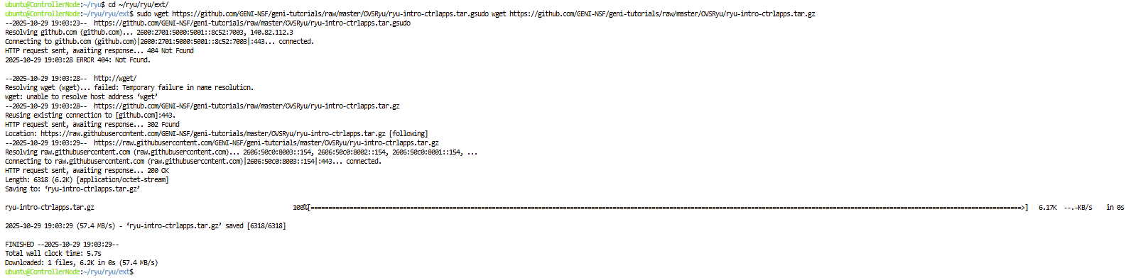
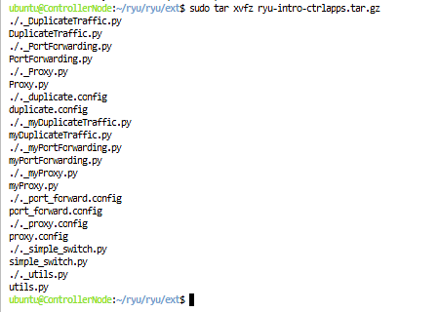

2.5 Debugging your Controller
- Print messages
Run your controller in verbose mode (add --verbose) and add print messages at various places to see what your controller is seeing.
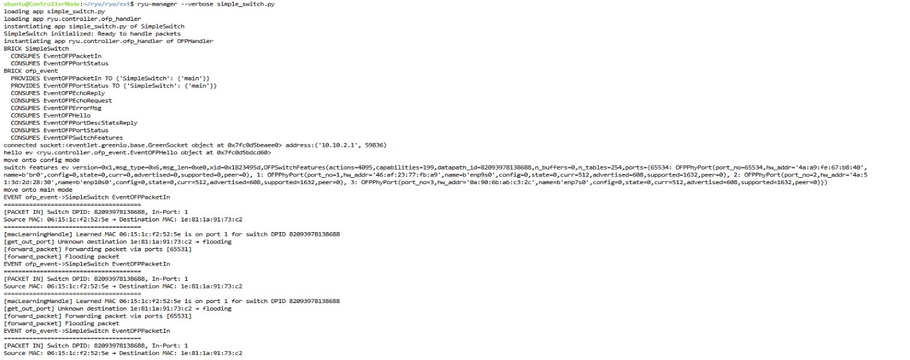
- Check the status in the switch
If you are using an OVS switch, you can dump information from your switch. For example, to dump the flows:
sudo ovs-ofctl dump-flows br0
Two other useful commands show you the status of your switch:
sudo ovs-vsctl show
sudo ovs-ofctl show br0

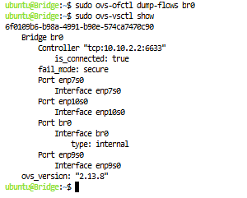

2.6 Run a traffic duplication controller
DuplicateTraffic.py to duplicate traffic: cd ~/ryu ryu-manager ryu/ext/myDuplicateTraffic.py
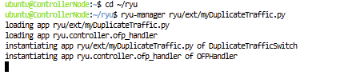
Duplication on host2 and host3
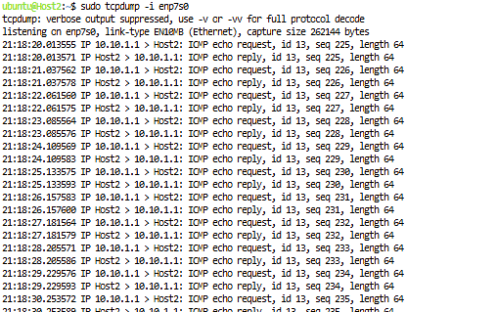
Ping from host1 to host 2
- To test it go to the terminal of host1 and try to ping host2:
ping 10.10.1.2
If your controller is working, your packets will register in both terminals running tcpdump.
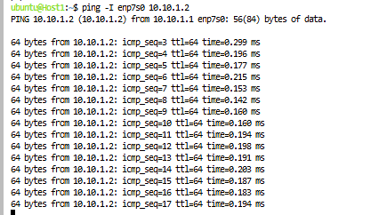
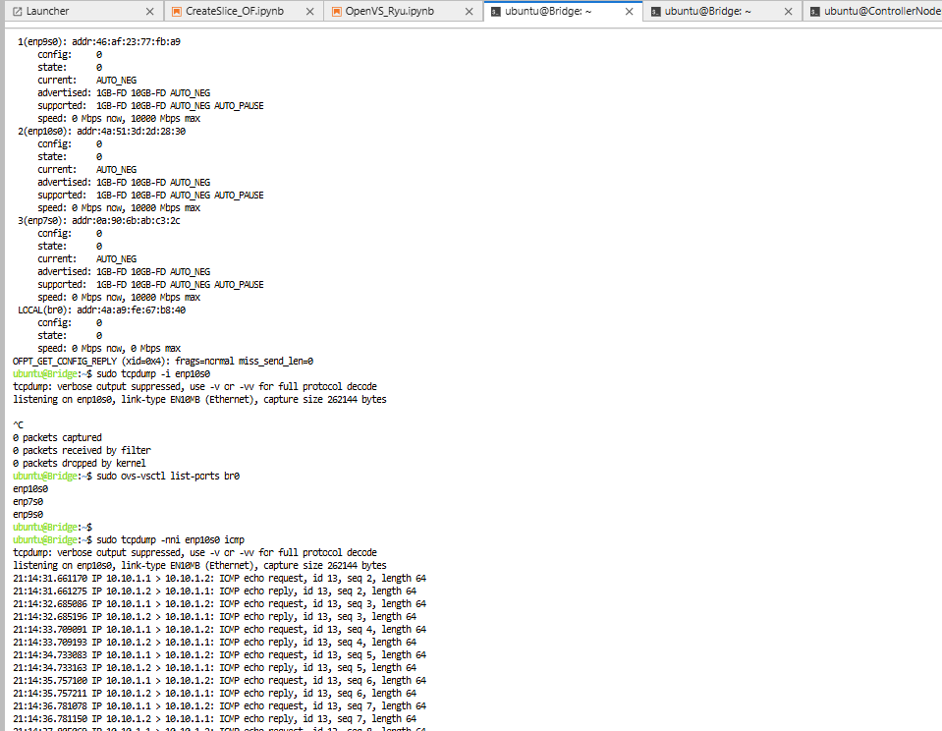
2.7 Run a port forward Controller
Before running:

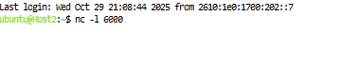
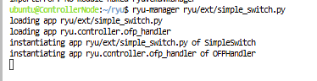
After running:

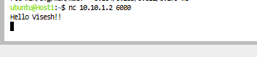


2.8 Run a Server Proxy Controller
Before running:
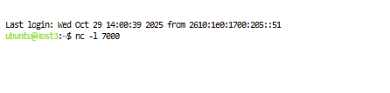
After running:
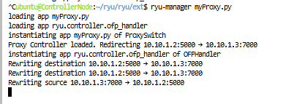

Host1 -> Host3

